**easyCBM for Migrant Educators and Directors**

**Using Reports: Getting Started and Finding the Item Analysis**

**Log in to www.mep.ney.easycbm.com**

* 1. User name
  2. Password

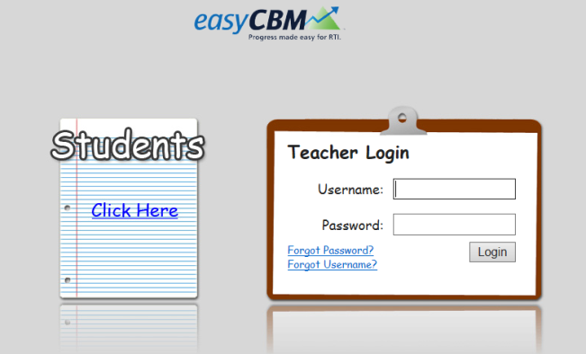

**Reports: Getting Started**

Select Reports from the top.

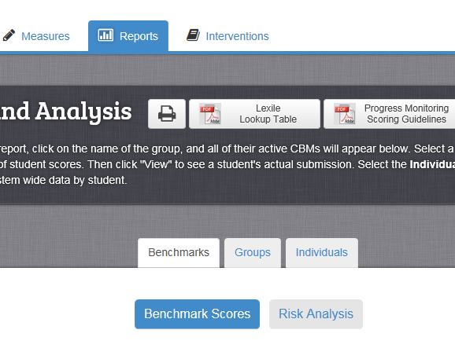

Then click on the Benchmarks Tab in the middle of the screen.

**Reports: Finding the Item Analysis - “Knowing What Your Students Know”**

There is an Item Analysis for two assessments:

* CCSS Math
* CCSS Reading Comprehension Item Analysis

The Item Analysis chart groups students by the areas they answered correctly and by the areas answered incorrectly.

***What to do:***

1. *Start by clicking on the Reports Tab at the top of the screen.*
2. Click on the **GROUP TAB** in the middle of the screen.
3. Click on the words, “All Students,” turning the whole line BLUE.
4. This chart shows all of the assessments that have scores entered, and how many students in the Educator’s Caseload, have a score for each assessment. (***Your screen*** will have the assessments and number of students to match ***what you entered.)***

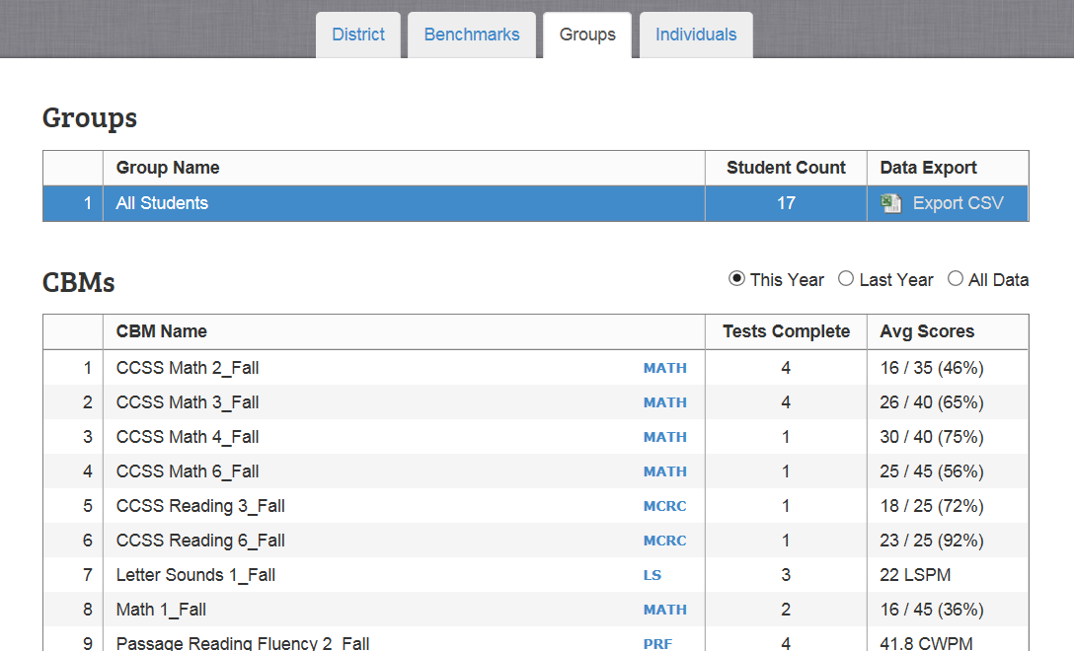

**f.**

**e.**

**d.**

**c.**

**b.**

1. **Click on one CCSS Math or CCSS Reading Comprehension Fall Assessment line.** (Use a CCSS Math assessment for the pre-conference Math Exercise – selecting one student to find out which math areas the student needs to work on)
2. **Scroll down** to the Item Analysis. (The screen doesn’t change. You have to scroll down to find the Item Analysis.)
3. The **Item Analysis** chart starts with the test items grouped in the order of all of the questions students got right and ends with the test items that were incorrect.

***Note – If there isn’t an Item Analysis – either no assessments are entered, or just the score is entered, instead of the student’s actual responses.***

**i.**

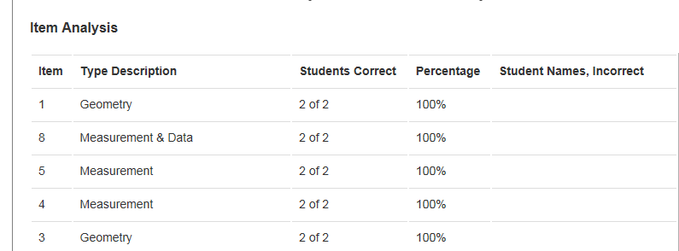

**g.**

1. ***You can re-sort the list by clicking on the column heading.***
2. ***In order to put all of the categories together*** and find which focus areas your students need help in, click on the column heading: TYPE DESCRIPTION.
3. ***This re-sorts the test items*** so all of the “Geometry” questions are together, all of the “Numbers and Operations” questions are together.
4. This lets you see which areas are the hardest for your student(s).

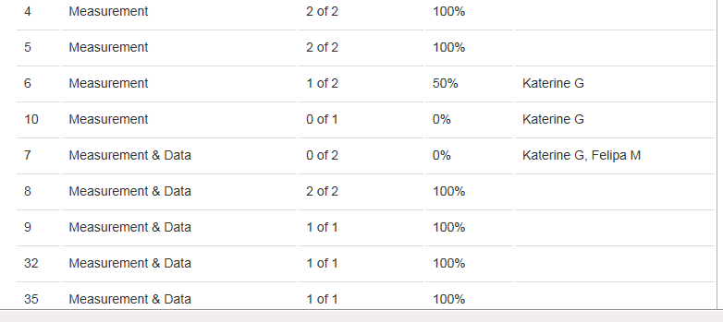

**k.**

***j.***

Student B

Student A

Student A

Student A

Note: The student name(s) are listed on the items that were incorrect.